EASY STAY:

1. Introduction
This report presents the analysis, design, and implementation of the Hotel Management System, developed as a final project for the Database II / System Analysis course. The system aims to automate hotel operations such as user management, reservations, billing, and services using an Oracle database and PL/SQL.
The project focuses on applying database concepts including tables, constraints, sequences, packages, functions, procedures, triggers, and exception handling in a real-world scenario.

2. Project Objectives
The main objectives of this project are: - Design a well-structured relational database for a hotel system - Apply SQL and PL/SQL concepts correctly - Use packages to organize functions and procedures - Implement triggers to enforce business rules - Handle exceptions and errors professionally - Provide clear documentation and reports

3. System Overview
The Hotel Management System supports the following core operations: - User registration and management - Room and reservation handling - Service management and billing - Payment and transaction tracking - Reporting and data retrieval
The system ensures data integrity through primary keys, foreign keys, and constraints, and improves performance and maintainability using stored database objects.
4. Database Design

4.1 Main Tables
The database consists of several related tables, including: - Users: Stores user and guest information - Rooms: Contains room details and availability - Reservations: Manages room bookings - Services: Represents hotel services - Bills: Tracks billing information - Transactions: Records payment transactions
Relationships between tables are enforced using foreign key constraints to maintain referential integrity.
4.2 Sequences
Sequences are used to generate unique identifiers for primary keys, such as: - user_seq - reservation_seq - service_seq

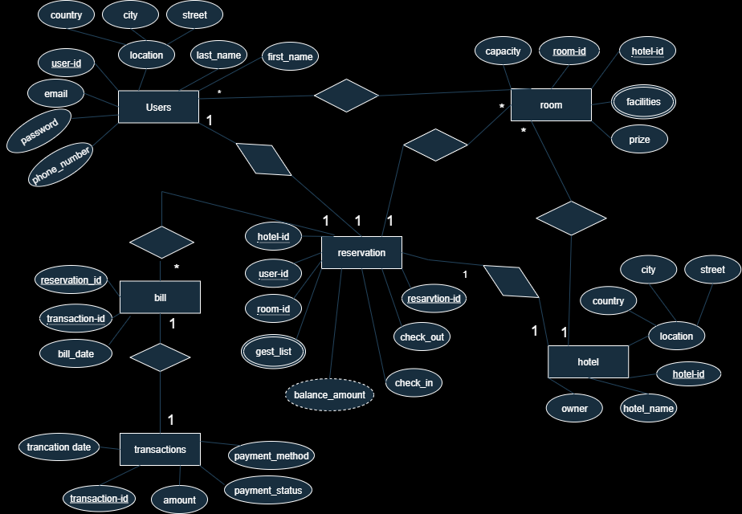

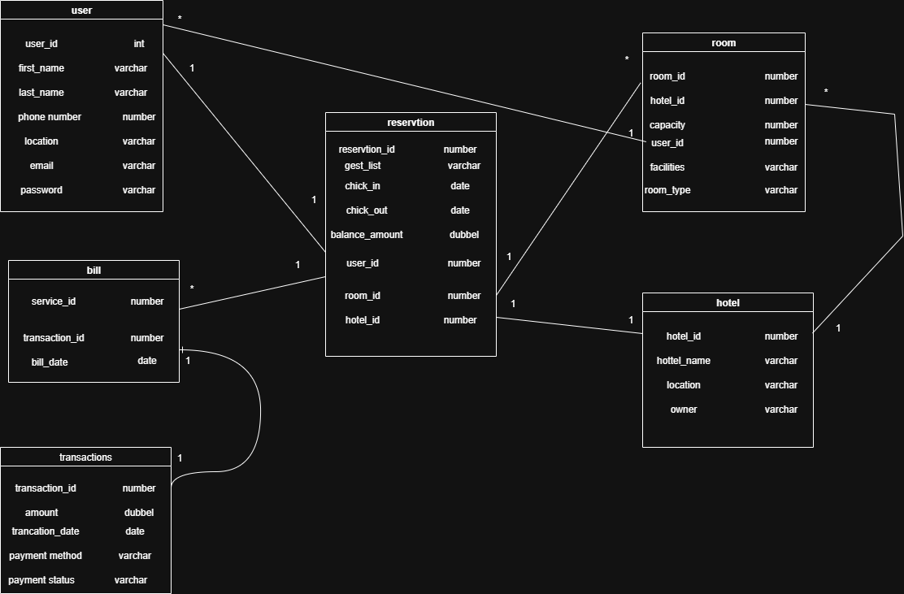

5. PL/SQL Implementation

5.1 Packages
Packages were used to group related logic for better organization and reusability.

Function Package
This package includes several functions such as: - Counting total users - Checking service billing status - Calculating stay duration - Getting service balance - Retrieving active guests

Procedure Package
This package contains procedures for: - Adding users - Deleting users - Creating reservations - Deleting reservations - Managing services and payments

6. Triggers
Triggers were implemented to enforce business rules and automate actions: - BEFORE INSERT triggers to validate data - AFTER INSERT triggers to log operations - AFTER UPDATE / DELETE triggers to maintain consistency
These triggers help prevent invalid data entry and ensure system reliability.

7. Exception Handling
Exception handling was applied in functions and procedures to manage runtime errors such as: - NO_DATA_FOUND – RAIS_APPLICTION_ERROR- INVALID_INPUT
Custom error messages were used to improve debugging and user feedback.

8. Testing and Validation
The system was tested using multiple SQL and PL/SQL calls: - Valid and invalid insert operations - Function calls using DBMS_OUTPUT - Procedure execution tests
All modules were validated to ensure correct outputs and error handling.

Hotel Management System – Final Project Report

9. Team Contribution
The project was developed through effective collaboration among the team members, with clear roles and responsibilities assigned from the beginning.

Team Structure
- Team Leader: Abdulrhman
- Co-Leader: Yossef Yasser
- Members: Hager, Rodina, Ahmed Noor, Ahmed Hossam, Mohaned

Contribution Details
All team members actively participated in the system analysis, database design, implementation, testing, and documentation phases of the project. Tasks were distributed fairly, and most members showed strong commitment throughout the project lifecycle.
A mid-term meeting was conducted to explain the complete system, including database schema, packages, procedures, and triggers. The trigger logic and functionality were clearly explained during this meeting.
However:
- Ahmed Hossam showed limited interaction during the project. He did not attend the mid-term meeting, did not submit the required SQL queries, and did not complete his assigned tasks.
- Mohaned did not attend the mid-term meeting where triggers were explained, but he contributed to other parts of the project.
To ensure successful project completion, the remaining active members coordinated effectively, and the leadership team ensured that all missing tasks were covered and finalized on time.
Overall, the project was successfully delivered through teamwork, leadership, and strong collaboration among the active members.

10. Conclusion
The Hotel Management System project successfully demonstrates the practical application of database and system analysis concepts. The system is efficient, well-structured, and follows best practices in SQL and PL/SQL development.
This project enhanced our understanding of database design, PL/SQL programming, and teamwork in a real-world system development environment.

11. References
- Oracle Database PL/SQL Documentation
- Course Materials – Database II

Table

create table users (
user_id number primary key,
first_name varchar2(50),
last_name varchar2(50),
phone_number number(20),
location varchar2(100),
email varchar2(100) unique,
password varchar2(200)
);

create sequence user_seq start with 1 increment by 1 nocycle;

insert into users values (user_seq.nextval,'Ahmed','Ali',0101,'Cairo','ahmed@mail.com','Test@123');
-----------------------------------------------------------------------------------------------------
insert into users values (user_seq.nextval,'Mohamed','Hassan',0102,'Giza','mohamed@mail.com','Pass@456');
----------------------------------------------------------------------------------------------------------
insert into users values (user_seq.nextval,'Sara','Mahmoud',0103 ,'Alex','sara@mail.com','Sara@789');
----------------------------------------------------------------------------------------------------
insert into users values (user_seq.nextval,'Omar','Youssef',0104,'Cairo','omar@mail.com','Omar@321');
--------------------------------------------------------------------------------------------------------
insert into users values (user_seq.nextval,'Mona','Ibrahim',0105,'Tanta','mona@mail.com','Mona@654');
-------------------------------------------------------------------------------------------------------
insert into users values (user_seq.nextval,'Khaled','Sayed',0106,'Mansoura','khaled@mail.com','Khaled@987');
-------------------------------------------------------------------------------------------------------------
insert into users values (user_seq.nextval,'Nour','Adel',0107,'Cairo','nour@mail.com','Nour@159');
--------------------------------------------------------------------------------------------------
insert into users values (user_seq.nextval,'Hala','Fathy',0108,'Giza','hala@mail.com','Hala@753');
---------------------------------------------------------------------------------------------------------
insert into users values (user_seq.nextval,'Yassin','Mostafa',0109,'Aswan','yassin@mail.com','Yassin@852');
------------------------------------------------------------------------------------------------------------
insert into users values (user_seq.nextval,'Laila','Samir',0110,'Luxor','laila@mail.com','Laila@456');

--------------------------------------------------
--------------------------------------------------

-- hotel table
create table hotel (
hotel_id number primary key,
hotel_name varchar2(100),
location varchar2(100),
owner varchar2(100)
);

create sequence hotel_seq start with 1 increment by 1 nocycle;

insert into hotel values (hotel_seq.nextval,'Sunrise Hotel','Cairo','Hassan');
---------------------------------------------------------------------------------
insert into hotel values (hotel_seq.nextval,'Sea View','Alex','Omar');
--------------------------------------------------------------------------------------
insert into hotel values (hotel_seq.nextval,'Royal Stay','Giza','Adel');
------------------------------------------------------------------------
insert into hotel values (hotel_seq.nextval,'Blue Nile','Aswan','Mahmoud');
-----------------------------------------------------------------------------------
insert into hotel values (hotel_seq.nextval,'Golden Inn','Luxor','Khaled');
----------------------------------------------------------------------------
insert into hotel values (hotel_seq.nextval,'Sky Hotel','Cairo','Youssef');
--------------------------------------------------------------------------------------------
insert into hotel values (hotel_seq.nextval,'Palm Resort','Hurghada','Ali');
-----------------------------------------------------------------------------
insert into hotel values (hotel_seq.nextval,'Dream Hotel','Sharm','Mostafa');
------------------------------------------------------------------------------
insert into hotel values (hotel_seq.nextval,'City Lodge','Tanta','Fathy');
----------------------------------------------------------------------------------
insert into hotel values (hotel_seq.nextval,'Moon Light','Mansoura','Samir');

--------------------------------------------------
--------------------------------------------------

-- room table
create table room (
room_id number primary key,
hotel_id number,
capacity number,
user_id number,
facilities varchar2(200),
room_type varchar2(100),
constraint fk_room_hotel foreign key (hotel_id) references hotel(hotel_id),
constraint fk_user_room foreign key (user_id) references users(user_id));

create sequence room_seq start with 1 increment by 1 nocycle;

INSERT INTO room
(room_id, hotel_id, capacity, user_id, facilities, room_type)
VALUES
(room_seq.NEXTVAL, 1, 2, 1, 'AC,TV', 'Single');
INSERT INTO room
(room_id, hotel_id, capacity, user_id, facilities, room_type)
VALUES
(room_seq.NEXTVAL, 2, 3, 2, 'AC,Sea View', 'Double');

INSERT INTO room
(room_id, hotel_id, capacity, user_id, facilities, room_type)
VALUES
(room_seq.NEXTVAL, 3, 2, 3, 'WiFi', 'Single');

INSERT INTO room
(room_id, hotel_id, capacity, user_id, facilities, room_type)
VALUES
(room_seq.NEXTVAL, 4, 4, 4, 'AC,TV,WiFi', 'Suite');

INSERT INTO room
(room_id, hotel_id, capacity, user_id, facilities, room_type)
VALUES
(room_seq.NEXTVAL, 5, 1, 5, 'TV', 'Single');

INSERT INTO room
(room_id, hotel_id, capacity, user_id, facilities, room_type)
VALUES
(room_seq.NEXTVAL, 6, 2, 6, 'AC', 'Double');

INSERT INTO room
(room_id, hotel_id, capacity, user_id, facilities, room_type)
VALUES
(room_seq.NEXTVAL, 7, 3, 7, 'AC,Pool', 'Suite');

INSERT INTO room
(room_id, hotel_id, capacity, user_id, facilities, room_type)
VALUES
(room_seq.NEXTVAL, 8, 2, 8, 'WiFi', 'Single');

INSERT INTO room
(room_id, hotel_id, capacity, user_id, facilities, room_type)
VALUES
(room_seq.NEXTVAL, 9, 1, 9, 'AC', 'Single');

INSERT INTO room
(room_id, hotel_id, capacity, user_id, facilities, room_type)
VALUES
(room_seq.NEXTVAL, 10, 4, 10, 'AC,TV', 'Suite');

--------------------------------------------------
--------------------------------------------------

-- reservation table (15 inserts)
create table reservation (
reservation_id number primary key,
guest_list varchar2(200),
check_in date,
check_out date,
balance_amount number(10,2),
user_id number,
room_id number,
hotel_id number
);

create sequence reservation_seq start with 1 increment by 1 nocycle;

insert into reservation values (reservation_seq.nextval,'Ahmed Ali',date '2025-01-01',date '2025-01-05',1500,1,1,1);
--------------------------------------------------
insert into reservation values (reservation_seq.nextval,'Mohamed Hassan',date '2025-01-02',date '2025-01-06',2000,2,2,2);
--------------------------------------------------
insert into reservation values (reservation_seq.nextval,'Sara Mahmoud',date '2025-01-03',date '2025-01-04',1800,3,3,3);
--------------------------------------------------
insert into reservation values (reservation_seq.nextval,'Omar Youssef',date '2025-01-04',date '2025-01-07',2200,4,4,4);
--------------------------------------------------
insert into reservation values (reservation_seq.nextval,'Mona Ibrahim',date '2025-01-05',date '2025-01-08',900,5,5,5);
--------------------------------------------------
insert into reservation values (reservation_seq.nextval,'Khaled Sayed',date '2025-01-06',date '2025-01-09',1600,6,6,6);
--------------------------------------------------
insert into reservation values (reservation_seq.nextval,'Nour Adel',date '2025-01-07',date '2025-01-10',2500,7,7,7);
--------------------------------------------------
insert into reservation values (reservation_seq.nextval,'Hala Fathy',date '2025-01-08',date '2025-01-11',3000,8,8,8);
--------------------------------------------------
insert into reservation values (reservation_seq.nextval,'Yassin Mostafa',date '2025-01-09',date '2025-01-12',1200,9,9,9);
--------------------------------------------------
insert into reservation values (reservation_seq.nextval,'Laila Samir',date '2025-01-10',date '2025-01-13',2800,10,10,10);
--------------------------------------------------
insert into reservation values (reservation_seq.nextval,'Ahmed Ali',date '2025-02-01',date '2025-02-05',1500,1,2,2);
--------------------------------------------------
insert into reservation values (reservation_seq.nextval,'Mohamed Hassan',date '2025-02-02',date '2025-02-06',2000,2,3,3);
--------------------------------------------------
insert into reservation values (reservation_seq.nextval,'Sara Mahmoud',date '2025-02-03',date '2025-02-07',1800,3,4,4);
--------------------------------------------------
insert into reservation values (reservation_seq.nextval,'Omar Youssef',date '2025-02-04',date '2025-02-08',2200,4,5,5);
--------------------------------------------------
insert into reservation values (reservation_seq.nextval,'Mona Ibrahim',date '2025-02-05',date '2025-02-09',900,5,6,6);
--------------------------------------------------
insert into reservation values (reservation_seq.nextval,'Khaled Sayed', DATE '2025-01-01',DATE '2025-01-05',0, 3, 2,2);

--------------------------------------------------
--------------------------------------------------
-- transaction table
-------------------------------------------------------------
------------------------------------------------------------------
create table transactions (
transaction_id number primary key,
amount number(10,2),
transaction_date date,
payment_method VARCHAR2(30),
payment_status VARCHAR2(20)
);

create sequence transaction_seq start with 1 increment by 1 nocycle;

INSERT INTO transactions
(transaction_id, amount, transaction_date, payment_method, payment_status)
VALUES
(transaction_seq.NEXTVAL, 1500, DATE '2025-01-01', 'Cash', 'PAID');

INSERT INTO transactions
(transaction_id, amount, transaction_date, payment_method, payment_status)
VALUES
(transaction_seq.NEXTVAL, 2000, DATE '2025-01-02', 'Visa', 'PAID');

INSERT INTO transactions
(transaction_id, amount, transaction_date, payment_method, payment_status)
VALUES
(transaction_seq.NEXTVAL, 1800, DATE '2025-01-03', 'Wallet', 'PAID');

INSERT INTO transactions
(transaction_id, amount, transaction_date, payment_method, payment_status)
VALUES
(transaction_seq.NEXTVAL, 2200, DATE '2025-01-04', 'Cash', 'PENDING');

INSERT INTO transactions
(transaction_id, amount, transaction_date, payment_method, payment_status)
VALUES
(transaction_seq.NEXTVAL, 900, DATE '2025-01-05', 'Visa', 'PAID');

INSERT INTO transactions
(transaction_id, amount, transaction_date, payment_method, payment_status)
VALUES
(transaction_seq.NEXTVAL, 1600, DATE '2025-01-06', 'Cash', 'PAID');

INSERT INTO transactions
(transaction_id, amount, transaction_date, payment_method, payment_status)
VALUES
(transaction_seq.NEXTVAL, 2500, DATE '2025-01-07', 'Wallet', 'PAID');

INSERT INTO transactions
(transaction_id, amount, transaction_date, payment_method, payment_status)
VALUES
(transaction_seq.NEXTVAL, 3000, DATE '2025-01-08', 'Visa', 'PAID');

INSERT INTO transactions
(transaction_id, amount, transaction_date, payment_method, payment_status)
VALUES
(transaction_seq.NEXTVAL, 1200, DATE '2025-01-09', 'Cash', 'FAILED');

insert into transactions
(transaction_id, amount, transaction_date, payment_method, payment_status)
values
(transaction_seq.nextval,2800,date '2025-01-10','Visa','FAILED');
--------------------------------------------------
--bill table
create table bill (
bill_id number primary key,
reservation_id number,
transaction_id number,
bill_date date,
constraint fk_bill_res foreign key (reservation_id)
references reservation(reservation_id),
constraint fk_bill_trans foreign key (transaction_id)
references transactions(transaction_id)
);
-----------------------------------
create sequence bill_seq start with 1 increment by 1 nocycle;

INSERT INTO bill
(bill_id, reservation_id, transaction_id, bill_date)
VALUES
(bill_seq.NEXTVAL, 1, 1, DATE '2025-01-01');

INSERT INTO bill
(bill_id, reservation_id, transaction_id, bill_date)
VALUES
(bill_seq.NEXTVAL, 2, 2, DATE '2025-01-02');

INSERT INTO bill
(bill_id, reservation_id, transaction_id, bill_date)
VALUES
(bill_seq.NEXTVAL, 3, 3, DATE '2025-01-03');

INSERT INTO bill
(bill_id, reservation_id, transaction_id, bill_date)
VALUES
(bill_seq.NEXTVAL, 4, 4, DATE '2025-01-04');

INSERT INTO bill
(bill_id, reservation_id, transaction_id, bill_date)
VALUES
(bill_seq.NEXTVAL, 5, 5, DATE '2025-01-05');

INSERT INTO bill
(bill_id, reservation_id, transaction_id, bill_date)
VALUES
(bill_seq.NEXTVAL, 6, 6, DATE '2025-01-06');

INSERT INTO bill
(bill_id, reservation_id, transaction_id, bill_date)
VALUES
(bill_seq.NEXTVAL, 7, 7, DATE '2025-01-07');

INSERT INTO bill
(bill_id, reservation_id, transaction_id, bill_date)
VALUES
(bill_seq.NEXTVAL, 8, 8, DATE '2025-01-08');

INSERT INTO bill
(bill_id, reservation_id, transaction_id, bill_date)
VALUES
(bill_seq.NEXTVAL, 9, 9, DATE '2025-01-09');

INSERT INTO bill
(bill_id, reservation_id, transaction_id, bill_date)
VALUES
(bill_seq.NEXTVAL, 10, 10, DATE '2025-01-10');

--------------------------------------------------
--------------------------------------------------
--------------------------------------------------
-- select all data
select * from users;
--------------------------------------------------
select * from hotel;
--------------------------------------------------
select * from room;
--------------------------------------------------
select * from reservation;
--------------------------------------------------
select * from transactions;
--------------------------------------------------
select * from bill;
----------------------------------------------
----------------------------------------------
----------------------------------------------
--------------------------------------------------

-- drop tables
--
-- drop table bill cascade constraints;
-- drop table reservation cascade constraints;
-- drop table room cascade constraints;
-- drop table hotel cascade constraints;
-- drop table users cascade constraints;
-- drop table transactions cascade constraints;
----
----------------------------------------------------
---- drop sequences
--
-- drop sequence bill_seq;
-- drop sequence reservation_seq;
-- drop sequence room_seq;
-- drop sequence hotel_seq;
-- drop sequence user_seq;
-- drop sequence transaction_seq;

--
--------------------------------------------------
----------------------------------------------

Query:
-- queries

-- Total revenue 1 ?????? ?????? ???? ???? ??????? ahmed hossam
select sum(amount) as total_revenue
from transactions;

--------------------------------------------------

-- Number of bookings per hotel 2 ??? ???????? ?? ?? ???? ahmed hossam
select h.hotel_name, count(r.reservation_id) total_bookings
from hotel h
join reservation r
on h.hotel_id = r.hotel_id
group by h.hotel_name;

----

-- Booking details with the user and the hotel 3 ?????? ????? ?? ??? ???????? ???? ?????? ahmed noor
select u.first_name || ' ' || u.last_name user_name,
h.hotel_name,
r.check_in,
r.check_out,
r.balance_amount
from reservation r
join users u on r.user_id = u.user_id
join hotel h on r.hotel_id = h.hotel_id;

--------------------------------------------------

-- All rooms, even those booked 4 ?? ????? ??? ???? ??????? mohnad
select rm.room_id,
h.hotel_name,
r.reservation_id
from room rm join reservation r
on rm.room_id = r.room_id
join hotel h
on rm.hotel_id = h.hotel_id;

--------------------------------------------------

-- Users who made reservations 5 ?????????? ???? ????? ?????? mohned
select *
from users
where user_id in (
select user_id from reservation
);

--------------------------------------------------

-- Invoice and payment details mony payed and balance_amount 6 ?????? ???????? ?????? hager
select u.first_name,
h.hotel_name,
t.amount,
r.check_in,
r.check_out,
balance_amount
from bill b
join transactions t on b.transaction_id = t.transaction_id
join reservation r on b.reservation_id = r.reservation_id
join users u on r.user_id = u.user_id
join hotel h on r.hotel_id = h.hotel_id;

--------------------------------------------------

-- user more reservation in system 7 ??????? ???? ??? ???? ?????? yossef yasser
select u.first_name,
count(r.reservation_id) booking_count
from users u
join reservation r
on u.user_id = r.user_id
group by u.first_name
order by booking_count desc
fetch first 1 row only;

--------------------------------------------------

-- more balnce amout reservation 8 ???? ??? ?? ??????? rodina
select *
from reservation
where balance_amount = (
select max(balance_amount)
from reservation
);

--------------------------------------------------

-- number of reservation for each user 10 ??? ???????? ??? ?????? rodina
select u.first_name,
count(r.reservation_id) booking_count
from users u
left join reservation r
on u.user_id = r.user_id
group by u.first_name;

--return all users payment status FAILED 11 ??????? ???? ?????? abdo
SELECT
u.first_name || ' ' || u.last_name AS user_name,
u.phone_number,
h.hotel_name,
t.payment_status
FROM users u
JOIN reservation r
ON u.user_id = r.user_id
JOIN bill b
ON r.reservation_id = b.reservation_id
JOIN transactions t
ON b.transaction_id = t.transaction_id
JOIN hotel h
ON r.hotel_id = h.hotel_id
WHERE t.payment_status = 'FAILED';

select * from transactions;

function package:
CREATE OR REPLACE PACKAGE hotel_plsql_pkg
IS
-- Task 1 yossef
FUNCTION count_total_users
RETURN NUMBER;

-- Task 2
FUNCTION check_reservation_billing (
p_reservation_id IN NUMBER
) RETURN VARCHAR2;

-- Task 3
FUNCTION calculate_stay_duration (
p_check_in IN DATE,
p_check_out IN DATE
) RETURN NUMBER;

-- Task 4
FUNCTION get_reservation_balance (
p_reservation_id IN NUMBER
) RETURN NUMBER;

-- Task 5
FUNCTION get_active_guests
RETURN NUMBER;

-- Task 6
FUNCTION get_reservations_by_location (
p_location IN VARCHAR2
) RETURN NUMBER;

-- Task 7
FUNCTION calculate_total_revenue
RETURN NUMBER;
--task 8 abdo hossam
FUNCTION give_guest_by_room_id (p_id IN room.room_id%TYPE)
RETURN VARCHAR2;
END hotel_plsql_pkg;

----------------------------------------------------------------------

CREATE OR REPLACE PACKAGE BODY hotel_plsql_pkg
IS
-- Task 1: Count Total Users yossef
FUNCTION count_total_users
RETURN NUMBER
IS
v_count NUMBER;
BEGIN
SELECT COUNT(*) INTO v_count FROM users;
RETURN v_count;
EXCEPTION
WHEN OTHERS THEN
RETURN -1;
END;

-- Task 2: Check Reservation Billing Status ahmed hossam
FUNCTION check_reservation_billing (
p_reservation_id IN NUMBER
) RETURN VARCHAR2
IS
v_count NUMBER;
BEGIN
SELECT COUNT(*)
INTO v_count
FROM bill
WHERE reservation_id = p_reservation_id;

IF v_count > 0 THEN
RETURN 'payed';
ELSE
RETURN 'Not payd';
END IF;
EXCEPTION
WHEN OTHERS THEN
RETURN 'Error';
END;

-- Task 3: Calculate Stay Duration mohned
FUNCTION calculate_stay_duration (
p_check_in IN DATE,
p_check_out IN DATE
) RETURN NUMBER
IS
BEGIN
RETURN p_check_out - p_check_in;
EXCEPTION
WHEN OTHERS THEN
RETURN 0;
END;

-- Task 4: Get Reservation Balance hager
FUNCTION get_reservation_balance (
p_reservation_id IN NUMBER
) RETURN NUMBER
IS
v_balance NUMBER;
BEGIN
SELECT balance_amount
INTO v_balance
FROM reservation
WHERE reservation_id = p_reservation_id;

RETURN v_balance;
EXCEPTION
WHEN NO_DATA_FOUND THEN
RETURN 0;
WHEN OTHERS THEN
RETURN -1;
END;

-- Task 5: Get Active Guests rodina
FUNCTION get_active_guests
RETURN NUMBER
IS
v_count NUMBER;
BEGIN
SELECT COUNT(*)
INTO v_count
FROM reservation ;

RETURN v_count;
EXCEPTION
WHEN OTHERS THEN
RETURN 0;
END;

-- Task 6: Get Reservations by Location abdo hossam
FUNCTION get_reservations_by_location (
p_location IN VARCHAR2
) RETURN NUMBER
IS
v_count NUMBER;
BEGIN
SELECT COUNT(*)
INTO v_count
FROM reservation r
JOIN hotel h ON r.hotel_id = h.hotel_id
WHERE h.location = p_location;

RETURN v_count;
EXCEPTION
WHEN OTHERS THEN
RETURN 0;
END;

-- Task 7: Calculate Total Revenue ahmed noor
FUNCTION calculate_total_revenue
RETURN NUMBER
IS
v_total NUMBER;
BEGIN
SELECT SUM(amount)
INTO v_total
FROM transactions;

RETURN NVL(v_total, 0);
EXCEPTION
WHEN OTHERS THEN
RETURN 0;
END;
----------------------------------------

FUNCTION give_guest_by_room_id (p_id IN room.room_id%TYPE)
RETURN VARCHAR2
IS
v_room_id NUMBER;
v_name VARCHAR2 (40);
BEGIN
SELECT room_id, first_name || ' ' || last_name
INTO v_room_id, v_name
FROM room r JOIN users u ON r.user_id = u.USER_ID
WHERE room_id = p_id;

RETURN v_name;
EXCEPTION
WHEN NO_DATA_FOUND THEN
RETURN 'No guest found for the given room ID.';
WHEN OTHERS THEN
RETURN 'An error occurred.';
END give_guest_by_room_id;

END hotel_plsql_pkg;

/

Package procedure:
CREATE OR REPLACE PACKAGE hotel_pkg
IS
--------------------------------------------------
-- add new user yossef yasser
--------------------------------------------------
PROCEDURE add_user
(
p_first_name IN users.first_name%TYPE,
p_last_name IN users.last_name%TYPE,
p_phone IN users.phone_number%TYPE,
p_location IN users.location%TYPE,
p_email IN users.email%TYPE,
p_password IN users.password%TYPE
);

--------------------------------------------------
-- add new hotel mohnad
--------------------------------------------------
PROCEDURE add_hotel
(
p_name IN hotel.hotel_name%TYPE,
p_location IN hotel.location%TYPE,
p_owner IN hotel.owner%TYPE
);

--------------------------------------------------
-- add new room ahmed noor
--------------------------------------------------
PROCEDURE add_room
(
p_hotel_id IN room.hotel_id%TYPE,
p_capacity IN room.capacity%TYPE,
p_facilities IN room.facilities%TYPE,
p_room_type IN room.room_type%TYPE
);

--------------------------------------------------
-- create reservation ahemd hossam
--------------------------------------------------
PROCEDURE create_reservation
(
p_guest_list IN varchar2,
p_check_in IN DATE,
p_check_out IN DATE,
p_balance IN NUMBER
);

--------------------------------------------------
-- search reservation by guest name ahmed hossam and abdo
--------------------------------------------------
PROCEDURE search_resarvation_by_guest
(
p_guest_name IN reservation.guest_list%TYPE
);

--------------------------------------------------
-- pay remaining balance abdulrhman hossam
--------------------------------------------------
PROCEDURE pay_remaining_balance
(
p_reservation_id IN reservation.reservation_id%TYPE,
p_payment_amount IN NUMBER
);

--------------------------------------------------
-- get users with remaining balance hager
--------------------------------------------------
PROCEDURE get_users_with_balance;

--------------------------------------------------
-- get all paid payments rodina
--------------------------------------------------
PROCEDURE get_paid_payments;

END hotel_pkg;
/

/
-------------------------------------------------------------------------------------------------------------
-------------------------------------------------------------------------------------------------------------
-------------------------------------------------------------------------------------------------------------

CREATE OR REPLACE PACKAGE BODY hotel_pkg
IS
--------------------------------------------------------

PROCEDURE add_user
(
p_first_name IN users.first_name%TYPE,
p_last_name IN users.last_name%TYPE,
p_phone IN users.phone_number%TYPE,
p_location IN users.location%TYPE,
p_email IN users.email%TYPE,
p_password IN users.password%TYPE
)
IS
BEGIN
INSERT INTO users
VALUES (
user_seq.NEXTVAL,
p_first_name,
p_last_name,
p_phone,
p_location,
p_email,
p_password
);
END add_user;

--------------------------------------------------------
PROCEDURE add_hotel
(
p_name IN hotel.hotel_name%TYPE,
p_location IN hotel.location%TYPE,
p_owner IN hotel.owner%TYPE
)
IS
BEGIN
INSERT INTO hotel
VALUES (
hotel_seq.NEXTVAL,
p_name,
p_location,
p_owner
);
END add_hotel;

--------------------------------------------------------
PROCEDURE add_room
(
p_hotel_id IN room.hotel_id%TYPE,
p_capacity IN room.capacity%TYPE,
p_facilities IN room.facilities%TYPE,
p_room_type IN room.room_type%TYPE
)
IS
BEGIN

INSERT INTO room
(
room_id,
hotel_id,
capacity,
facilities,
room_type
)
VALUES
(
room_seq.NEXTVAL,
p_hotel_id,
p_capacity,
p_facilities,
p_room_type
);
END add_room;

--------------------------------------------------------
PROCEDURE create_reservation
(
p_guest_list IN VARCHAR2,
p_check_in IN DATE,
p_check_out IN DATE,
p_balance IN NUMBER
)
IS
BEGIN
INSERT INTO reservation
(
reservation_id,
guest_list,
check_in,
check_out,
balance_amount
)
VALUES
(
reservation_seq.NEXTVAL,
p_guest_list,
p_check_in,
p_check_out,
p_balance
);
END create_reservation;

--------------------------------------------------------
PROCEDURE search_resarvation_by_guest
(
p_guest_name IN reservation.guest_list%TYPE
)
IS
CURSOR c_res IS
SELECT r.guest_list,
r.check_in,
r.check_out,
h.hotel_name
FROM reservation r
JOIN hotel h ON r.hotel_id = h.hotel_id
WHERE r.guest_list = p_guest_name;

v_rec c_res%ROWTYPE;
BEGIN
OPEN c_res;
LOOP
FETCH c_res INTO v_rec;
EXIT WHEN c_res%NOTFOUND;

DBMS_OUTPUT.PUT_LINE(
v_rec.guest_list || ' | ' ||
v_rec.hotel_name || ' | ' ||
v_rec.check_in || ' -> ' ||
v_rec.check_out
);
END LOOP;
CLOSE c_res;
END search_resarvation_by_guest;

--------------------------------------------------------
PROCEDURE pay_remaining_balance
(
p_reservation_id IN reservation.reservation_id%TYPE,
p_payment_amount IN NUMBER
)
IS
v_balance reservation.balance_amount%TYPE;
BEGIN
SELECT balance_amount
INTO v_balance
FROM reservation
WHERE reservation_id = p_reservation_id;

IF p_payment_amount > v_balance THEN
RAISE_APPLICATION_ERROR(-20001,'Amount greater than balance');
END IF;

UPDATE reservation
SET balance_amount = balance_amount - p_payment_amount
WHERE reservation_id = p_reservation_id;

INSERT INTO transactions
(
transaction_id,
amount,
transaction_date,
payment_method,
payment_status
)
VALUES
(
transaction_seq.NEXTVAL,
p_payment_amount,
SYSDATE,
'Cash',
'PAID'
);

INSERT INTO bill
(
bill_id,
reservation_id,
transaction_id,
bill_date
)
VALUES
(
bill_seq.NEXTVAL,
p_reservation_id,
transaction_seq.CURRVAL,
SYSDATE
);
END pay_remaining_balance;

--------------------------------------------------------
PROCEDURE get_users_with_balance
IS
CURSOR c_users IS
SELECT u.first_name,
u.last_name,
u.phone_number,
r.balance_amount
FROM users u
JOIN reservation r ON u.user_id = r.user_id
WHERE r.balance_amount > 0;

v_user c_users%ROWTYPE;
BEGIN
OPEN c_users;
LOOP
FETCH c_users INTO v_user;
EXIT WHEN c_users%NOTFOUND;

DBMS_OUTPUT.PUT_LINE(
v_user.first_name || ' ' ||
v_user.last_name || ' | ' ||
v_user.phone_number ||
' | Balance: ' || v_user.balance_amount
);
END LOOP;
CLOSE c_users;
END get_users_with_balance;

--------------------------------------------------------

PROCEDURE get_paid_payments
IS
CURSOR paid_payments_cur IS
SELECT
u.first_name || ' ' || u.last_name AS full_name,
t.amount,
t.payment_status
FROM transactions t
JOIN bill b ON t.transaction_id = b.transaction_id
JOIN reservation r ON b.reservation_id = r.reservation_id
JOIN users u ON r.user_id = u.user_id
WHERE t.payment_status = 'PAID';

v_payment_rec paid_payments_cur%ROWTYPE;
BEGIN
OPEN paid_payments_cur;
LOOP
FETCH paid_payments_cur INTO v_payment_rec;
EXIT WHEN paid_payments_cur%NOTFOUND;

DBMS_OUTPUT.PUT_LINE(
'Name: ' || v_payment_rec.full_name ||
' | Amount: ' || v_payment_rec.amount ||
' | Status: ' || v_payment_rec.payment_status
);
END LOOP;
CLOSE paid_payments_cur;
END get_paid_payments;

END hotel_pkg;

